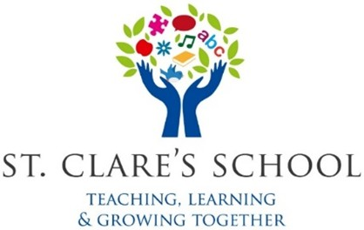
St Clare’s School

ENROLMENT REQUEST FORM - 2026/2027
Please be aware this is not an enrolment form. Enrolment forms will be issued should a place be offered.

Student Details
Name of student: ___________________________ Date of Birth: _________________________
Address (at which the applicant resides): _____________________________________________
______________________________________________Eircode: ___________________________

Psychological Report with recommendation for Placement in a Special School: Yes [ ] No [ ]
Psychological Report enclosed: Yes [ ] No [ ]
Name of Psychologist and Date of Assessment: __________________________________________
NCSE Eligibility letter (September 2026) included: Yes [ ] No [ ]

Parent(s)/Guardian(s) Details
Name: ______________________________________ [ ] Parent [ ] Custodian [ ] Legal Guardian
Address: ________________________________________________________________________
Home Tel. ________________ Mobile __________________ Email. ________________________

I have read the Admission’s Policy of St Clare’s School and I agree to abide by its content: Yes [ ] No [ ]

Completed enrolment applications must be returned by email: info@stclaresschool.ie
Or by post to: Admissions, St Clare’s School, Gort Road, Ennis, Co. Clare. V95YP83
By no later than 5pm Friday 19th December 2026.
Please ensure you receive an email from the school to confirm receipt of your request for enrolment.

